**Report**

* Use Postman and generate ten (10) unique API calls (using a different route each time).

1. Get FACTORS : GET <https://api.carbonintensity.org.uk/intensity/factors>

1. Get Carbon Intensity data for current half hour for England : GET <https://api.carbonintensity.org.uk/regional/england>

1. Get Carbon Intensity data for current half hour for specified postcode: GET <https://api.carbonintensity.org.uk/regional/postcode/RG10>

1. Get Carbon Intensity data for current half hour for specified region: GET <https://api.carbonintensity.org.uk/regional/regionid/6>

1. Get Carbon Intensity data for next 24h: GET <https://api.carbonintensity.org.uk/regional/intensity/2021-11-27T05:00Z/fw24h>

1. Get Carbon Intensity data for next 24h for specified region: GET <https://api.carbonintensity.org.uk/regional/intensity/2021-11-27T05:00Z/fw24h/regionid/3>

1. Get Carbon Intensity statistics between from and to datetime: GET <https://api.carbonintensity.org.uk/intensity/stats/2018-01-20T12:00Z/2018-01-20T12:30Z>

1. Get block average Carbon Intensity statistics between from and to datetime: GET <https://api.carbonintensity.org.uk/intensity/stats/2018-01-20T12:00Z/2018-01-20T12:30Z/10>

1. Get Carbon Intensity data 24hrs in the past of a specific datetime: GET <https://api.carbonintensity.org.uk/intensity/2018-01-20T12:00Z/pt24h>

1. Get Carbon Intensity data for past 24h for specified region: GET <https://api.carbonintensity.org.uk/regional/intensity/2021-11-27T05:00Z/pt24h/regionid/3>

11. Get Carbon Intensity data for current half hour for Scotland : GET [https://api.carbonintensity.org.uk/regional/scotland](https://api.carbonintensity.org.uk/regional/scotland%20)

12.Get Carbon Intensity data for current half hour for Wales : GET [https://api.carbonintensity.org.uk/regional/wales](https://api.carbonintensity.org.uk/regional/wales%20)

*13.* Get Carbon Intensity data between specified datetimes for specified region: GET [*https://api.carbonintensity.org.uk/regional/intensity/2018-01-20T12:00Z/pt24h/regionid/3*](https://api.carbonintensity.org.uk/regional/intensity/2018-01-20T12:00Z/pt24h/regionid/3)

*14.* Get Carbon Intensity data for next 48h for specified region: [*GET https://api.carbonintensity.org.uk/regional/intensity/2021-01-20T12:00Z/fw48h/regionid/3*](GET%20https:/api.carbonintensity.org.uk/regional/intensity/2021-01-20T12:00Z/fw48h/regionid/3)

15. Get Carbon Intensity data for specific half hour period: GET <https://api.carbonintensity.org.uk/intensity/2018-01-20T12:00Z>

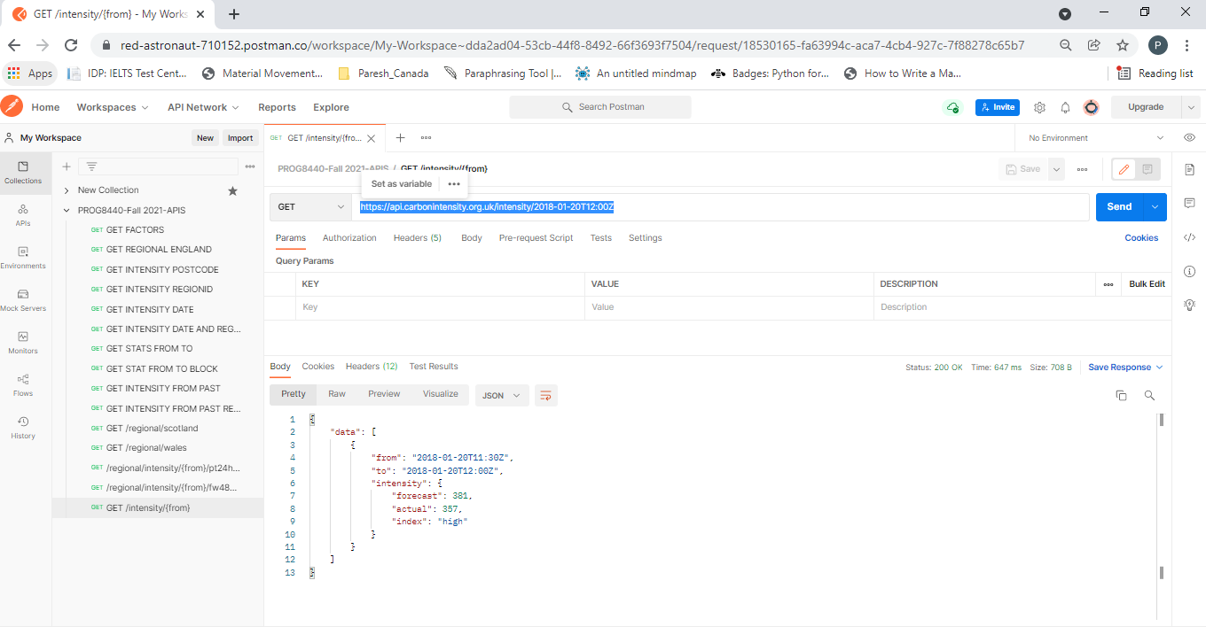

16. Get Carbon Intensity statistics between from and to datetime: GET <https://api.carbonintensity.org.uk/intensity/stats/2018-01-20T12:00Z/2018-01-20T12:30Z>

17. Get generation mix for the past 24 hours: GET <https://api.carbonintensity.org.uk/generation/2021-01-19T12:00Z/pt24h>

18. Get generation mix between from and to datetimes: GET <https://api.carbonintensity.org.uk/generation/2021-01-20T10:30Z/2021-01-20T11:00Z>

19. Get Carbon Intensity data for specific date and period: GET <https://api.carbonintensity.org.uk/intensity/date/2018-01-20T12:00Z/20>

* Python script of above API calls

import requests

#1

url = "https://api.carbonintensity.org.uk/intensity/factors"

payload={}

headers = {}

response = requests.request("GET", url, headers=headers, data=payload)

print(response.text)

#2

url = "https://api.carbonintensity.org.uk/regional/england"

payload={}

headers = {}

response = requests.request("GET", url, headers=headers, data=payload)

print(response.text)

#3

url = "https://api.carbonintensity.org.uk/regional/postcode/RG10"

payload={}

headers = {}

response = requests.request("GET", url, headers=headers, data=payload)

print(response.text)

#4

url = "https://api.carbonintensity.org.uk/regional/regionid/6"

payload={}

headers = {}

response = requests.request("GET", url, headers=headers, data=payload)

print(response.text)

#5

url = "https://api.carbonintensity.org.uk/regional/intensity/2021-11-27T05:00Z/fw24h"

payload={}

headers = {}

response = requests.request("GET", url, headers=headers, data=payload)

print(response.text)

#6

url = "https://api.carbonintensity.org.uk/regional/intensity/2021-11-27T05:00Z/fw24h/regionid/3"

payload={}

headers = {}

response = requests.request("GET", url, headers=headers, data=payload)

print(response.text)

#7

url = "https://api.carbonintensity.org.uk/intensity/stats/2018-01-20T12:00Z/2018-01-20T12:30Z"

payload={}

headers = {}

response = requests.request("GET", url, headers=headers, data=payload)

print(response.text)

#8

url = "https://api.carbonintensity.org.uk/intensity/stats/2018-01-20T12:00Z/2018-01-20T12:30Z/10"

payload={}

headers = {}

response = requests.request("GET", url, headers=headers, data=payload)

print(response.text)

#9

url = "https://api.carbonintensity.org.uk/intensity/2018-01-20T12:00Z/pt24h"

payload={}

headers = {}

response = requests.request("GET", url, headers=headers, data=payload)

print(response.text)

#10

url = "https://api.carbonintensity.org.uk/regional/intensity/2021-11-27T05:00Z/pt24h/regionid/3"

payload={}

headers = {}

response = requests.request("GET", url, headers=headers, data=payload)

print(response.text)

* Use PyTest to create tests. Create 19 passing tests plus 1 test that fails. For a total of 20 tests.

Script submitted.